UNIVERSITY OF WAH (UOW)

DEPARTMENT OF COMPUTER SCIENCE



BSCS 3RD B

REG #: UW-24-CS-BS-088

SUBMITTED BY: SAADI SAFDAR

SUBMITTED TO: SIR. HASSAN SHAFAQAT

COURSE TITLE: COMPUTER NETWORKS

COURSE CODE: CS – 241 L

LAB REPORT # 13, 14 & 15

Overview
This lab report contains five self-created practical tasks based on mandatory networking topics. Each task includes a unique instruction-based question, network design, IP addressing, device configuration, verification, and learning outcomes. All networks were implemented and tested in Cisco Packet Tracer.
Topics Covered:
- OSPF Dynamic Routing
- Wireless Router Connectivity
- BGP Dynamic Routing
- EIGRP Dynamic Routing
- Layer 3 NAT (Network Address Translation)

1. OSPF Dynamic Routing

1.1 Instruction-Type Question
Design and configure a three-router enterprise network using OSPF single-area routing. Each router must connect to a separate LAN. Implement dynamic routing using OSPF Area 0 and verify full end-to-end connectivity between all LAN hosts.

1.2 Reason for Choosing This Question
This question was selected to demonstrate practical implementation of OSPF, which is widely used in large-scale enterprise networks. The topology ensures multiple networks are involved, making dynamic routing necessary.

1.3 Network Topology
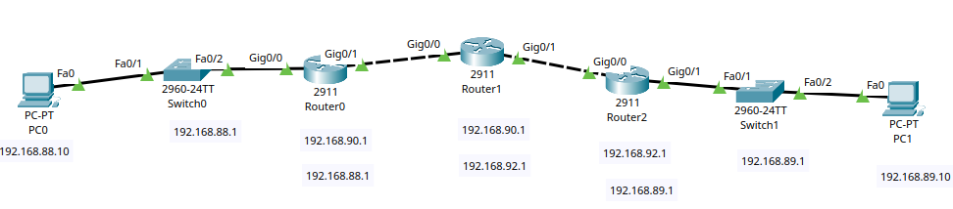

1.4 IP Addressing Scheme
Device | Interface | IP Address | Subnet Mask | Default Gateway
PC0 | Fa0 | 192.168.88.10 | 255.255.255.0 | 192.168.88.1
Switch0 | VLAN 1 | 192.168.88.1 | 255.255.255.0 | —
Router0 | Gig0/0 | 192.168.88.1 | 255.255.255.0 | —
Router0 | Gig0/1 | 192.168.90.1 | 255.255.255.252 | —
Router1 | Gig0/0 | 192.168.90.2 | 255.255.255.252 | —
Router1 | Gig0/1 | 192.168.92.1 | 255.255.255.252 | —
Router2 | Gig0/0 | 192.168.92.2 | 255.255.255.252 | —
Router2 | Gig0/1 | 192.168.89.1 | 255.255.255.0 | —
Switch1 | VLAN 1 | 192.168.89.1 | 255.255.255.0 | —
PC1 | Fa0 | 192.168.89.10 | 255.255.255.0 | 192.168.89.1

1.5 Verification and Testing
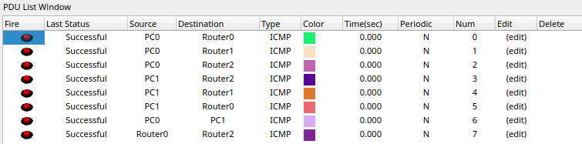

1.6 Conclusion and Learning Outcome
This task improved understanding of dynamic routing using OSPF and demonstrated efficient route exchange without manual configuration.

2. Wireless Router Connectivity

2.1 Instruction-Type Question
Design a wireless network using a wireless router and multiple wireless clients. Configure secure Wi-Fi using WPA2 encryption and ensure internet access through DHCP and NAT.

2.2 Reason for Choosing This Question
Wireless networking is essential in modern networks. This task demonstrates real-world Wi-Fi configuration and security implementation.

2.3 Network Topology
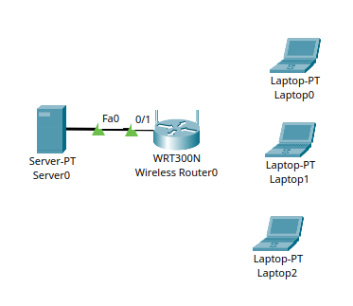

2.4 IP Addressing Scheme
DHCP Range: 192.168.1.100 – 192.168.1.200
Router Gateway: 192.168.1.1

2.5 Configuration
- Set SSID: CampusNet
- Security: WPA2-PSK
- Password: cnlab123
- DHCP Enabled

2.6 Conclusion and Learning Outcome
This task provided hands-on experience with wireless configuration, security, and client connectivity.

3. BGP Dynamic Routing

3.1 Instruction-Type Question
Create a two-autonomous system network using BGP. Configure eBGP peering between two edge routers and verify route exchange between both AS networks.

3.2 Reason for Choosing This Question
BGP is the backbone routing protocol of the internet. This task demonstrates inter-AS communication.

3.3 Network Topology
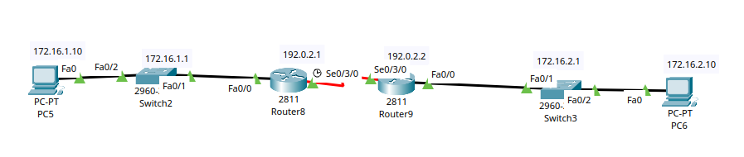

3.4 IP Addressing Scheme
Device | Interface | IP Address | Subnet Mask | Default Gateway
PC5 | Fa0 | 172.16.1.10 | 255.255.255.0 | 172.16.1.1
Switch2 | VLAN 1 | 172.16.1.1 | 255.255.255.0 | —
Router8 (AS 65001) | Fa0/0 | 172.16.1.1 | 255.255.255.0 | —
Router8 (AS 65001) | Se0/3/0 | 192.0.2.1 | 255.255.255.252 | —
Router9 (AS 65002) | Se0/3/0 | 192.0.2.2 | 255.255.255.252 | —
Router9 (AS 65002) | Fa0/0 | 172.16.2.1 | 255.255.255.0 | —
Switch3 | VLAN 1 | 172.16.2.1 | 255.255.255.0 | —
PC6 | Fa0 | 172.16.2.10 | 255.255.255.0 | 172.16.2.1

3.5 Verification
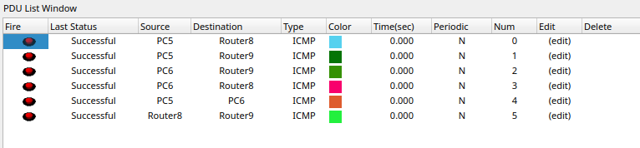

3.6 Conclusion
This task improved understanding of inter-domain routing using BGP.

4. EIGRP Dynamic Routing

4.1 Instruction-Type Question
Design a four-router network and implement EIGRP routing. Verify route convergence and redundancy.

4.2 Reason
EIGRP provides fast convergence and efficient routing in Cisco environments.

4.3 Topology
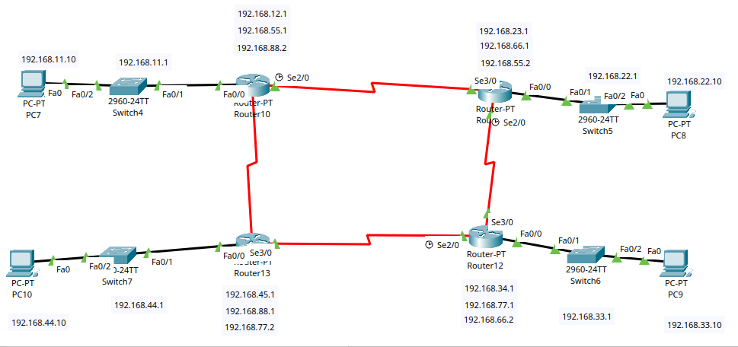

4.4 IP Addressing Scheme

Device | Interface | IP Address | Subnet Mask | Default Gateway
PC7 | Fa0 | 192.168.11.10 | 255.255.255.0 | 192.168.11.1
Switch4 | VLAN 1 | 192.168.11.1 | 255.255.255.0 | —
Router10 | Fa0/0 | 192.168.11.1 | 255.255.255.0 | —
Router10 | Se2/0 | 192.168.55.1 | 255.255.255.252 | —
Router10 | Se3/0 | 192.168.88.2 | 255.255.255.252 | —
Router11 | Se2/0 | 192.168.23.1 | 255.255.255.252 | —
Router11 | Fa0/0 | 192.168.22.1 | 255.255.255.0 | —
Switch5 | VLAN 1 | 192.168.22.1 | 255.255.255.0 | —
PC8 | Fa0 | 192.168.22.10 | 255.255.255.0 | 192.168.22.1
Router12 | Fa0/0 | 192.168.33.1 | 255.255.255.0 | —
Router12 | Se2/0 | 192.168.77.1 | 255.255.255.252 | —
Router12 | Se3/0 | 192.168.66.2 | 255.255.255.252 | —
Switch6 | VLAN 1 | 192.168.33.1 | 255.255.255.0 | —
PC9 | Fa0 | 192.168.33.10 | 255.255.255.0 | 192.168.33.1
Router13 | Fa0/0 | 192.168.44.1 | 255.255.255.0 | —
Router13 | Se2/0 | 192.168.45.1 | 255.255.255.252 | —
Router13 | Se3/0 | 192.168.88.1 | 255.255.255.252 | —
Switch7 | VLAN 1 | 192.168.44.1 | 255.255.255.0 | —
PC10 | Fa0 | 192.168.44.10 | 255.255.255.0 | 192.168.44.1

4.5 Verification
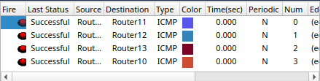

4.6 Conclusion
This task enhanced understanding of advanced Cisco routing techniques.

5. Layer 3 NAT

5.1 Instruction-Type Question
Design a private enterprise network using Layer 3 NAT to allow internal hosts to access the public internet.

5.2 Reason
NAT is critical for IP conservation and internet connectivity.

5.3 Topology
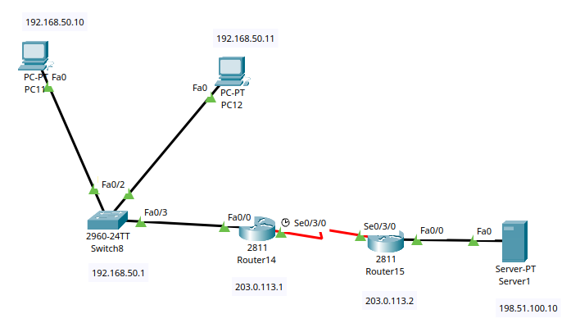

5.4 IP Addressing Scheme

Device | Interface | IP Address | Subnet Mask | Default Gateway
PC11 | Fa0 | 192.168.50.10 | 255.255.255.0 | 192.168.50.1
PC12 | Fa0 | 192.168.50.11 | 255.255.255.0 | 192.168.50.1
Switch8 | VLAN 1 | 192.168.50.1 | 255.255.255.0 | —
Router14 (NAT) | Fa0/0 | 192.168.50.1 | 255.255.255.0 | —
Router14 (NAT) | Se0/3/0 | 203.0.113.1 | 255.255.255.252 | —
Router15 (ISP) | Se0/3/0 | 203.0.113.2 | 255.255.255.252 | —
Router15 (ISP) | Fa0/0 | 198.51.100.1 | 255.255.255.0 | —
Server1 | Fa0 | 198.51.100.10 | 255.255.255.0 | 198.51.100.1

5.5 Configuration
R1:
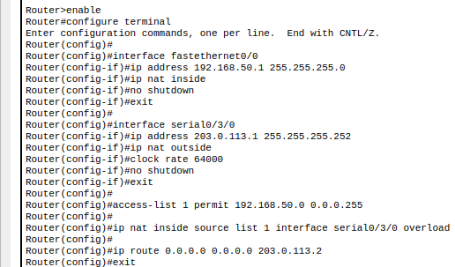
R2:
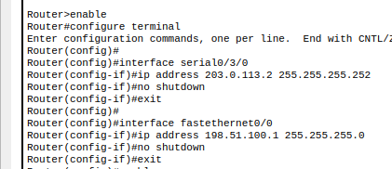

IP Summary:

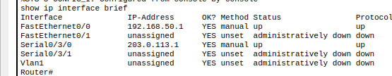

5.6 Verification
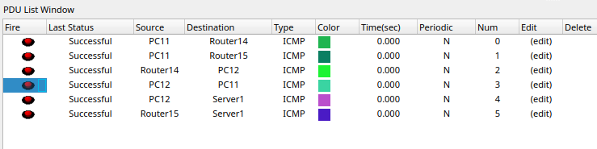

5.7 Conclusion and Learning Outcome
This task demonstrated real-world NAT configuration and public-private IP translation.

Final Conclusion
This lab strengthened practical knowledge of routing protocols, wireless networking, and NAT. It improved hands-on skills in designing, configuring, verifying, and troubleshooting real-world networks using Cisco Packet Tracer.

